ECO6112 Assignment 1
Yangbo Song
(Due date: September 28, 23:59)

- List all the strategies of each player in the following extensive-form game.

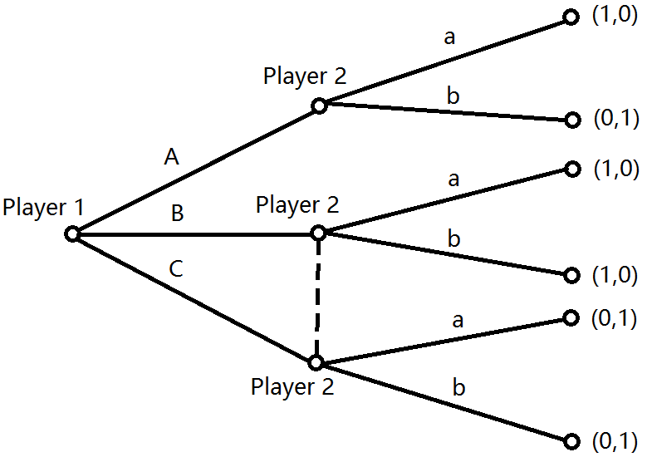

- Consider the following game:

 |  | Player 2
 |  | D | E
Player 1 | A | 1, 0 | 0, 2
Player 1 | B | 1, 1 | 2, 0
Player 1 | C | 0, 2 | 2, 1

- What is BR₁(D)?
- What is BR₁?
- Suppose that player 2 believes that player 1 will play A with probability p, B with probability q and C with probability 1-p-q. What is player 2’s best response as a function of p and q?

- Consider the following game:

 |  | Player 2
 |  | D | E
Player 1 | A | 3, 0 | 0, 2
Player 1 | B | 1, 1 | 1, 0
Player 1 | C | 0, 2 | 3, 1

- Which of player 1’s strategies is strictly dominated? List all the strategies that dominate it, except those that contain any mixture of itself.
- Consider any two-player game. Show that if a strategy is strictly dominated, it must be strictly dominated by infinitely many strategies.

- Consider the following Beauty Contest: there are many players who will each write a number a in [1, 2] simultaneously.
- Suppose that the payoff of each player is -(a - a)² where a is the average number. Is there any strictly dominated strategy for a player? If not, state your reasoning. If yes, list all the strictly dominated strategies.
- Suppose that the payoff of each player is -(a - 2a)² where a is the average number. Is there any strictly dominated strategy for a player? If not, state your reasoning. If yes, list all the strictly dominated strategies.

